# CS 255 System Design Document Template

## UML Diagrams

### UML Use Case Diagram

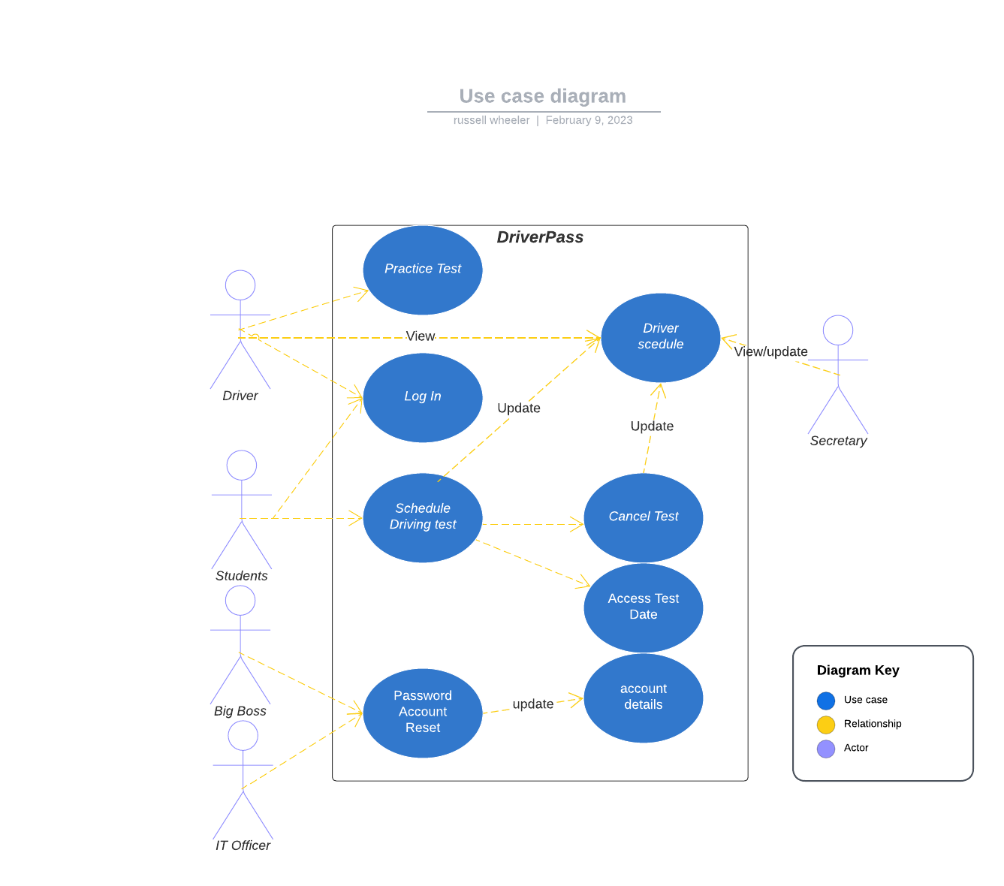

### UML Activity Diagrams

*The two use cases I have chosen are Login and Schedule Driving Test.*

***Login Diagram***

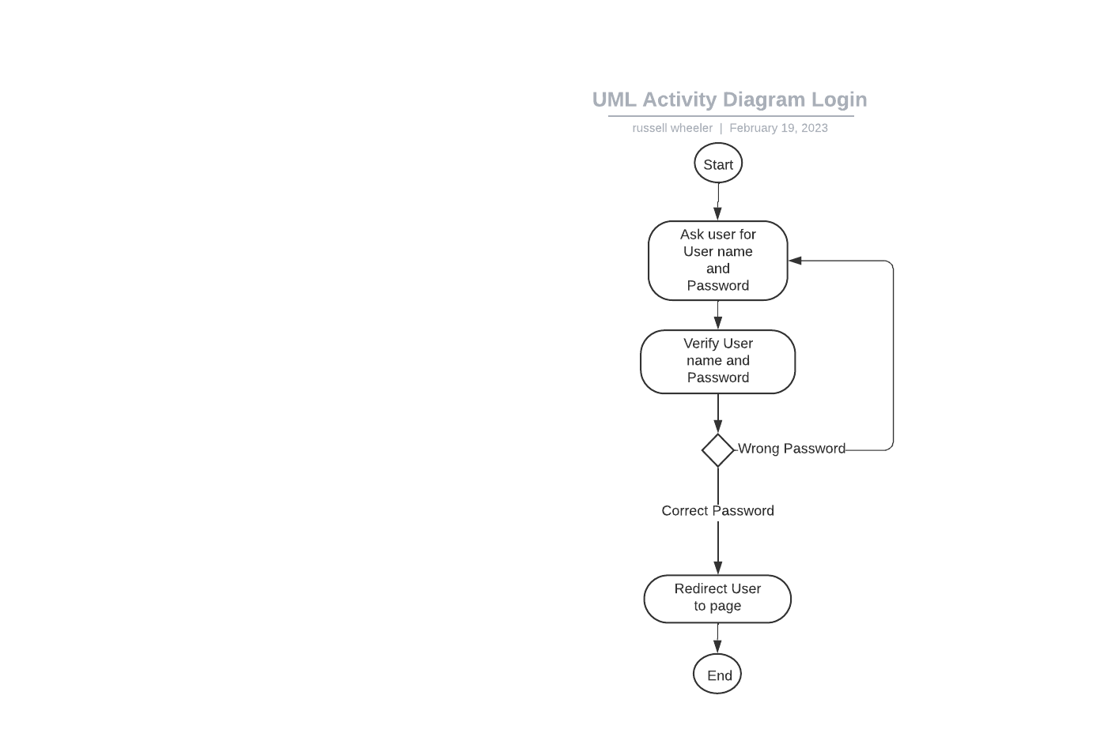

**Schedule Driving Test Diagram**

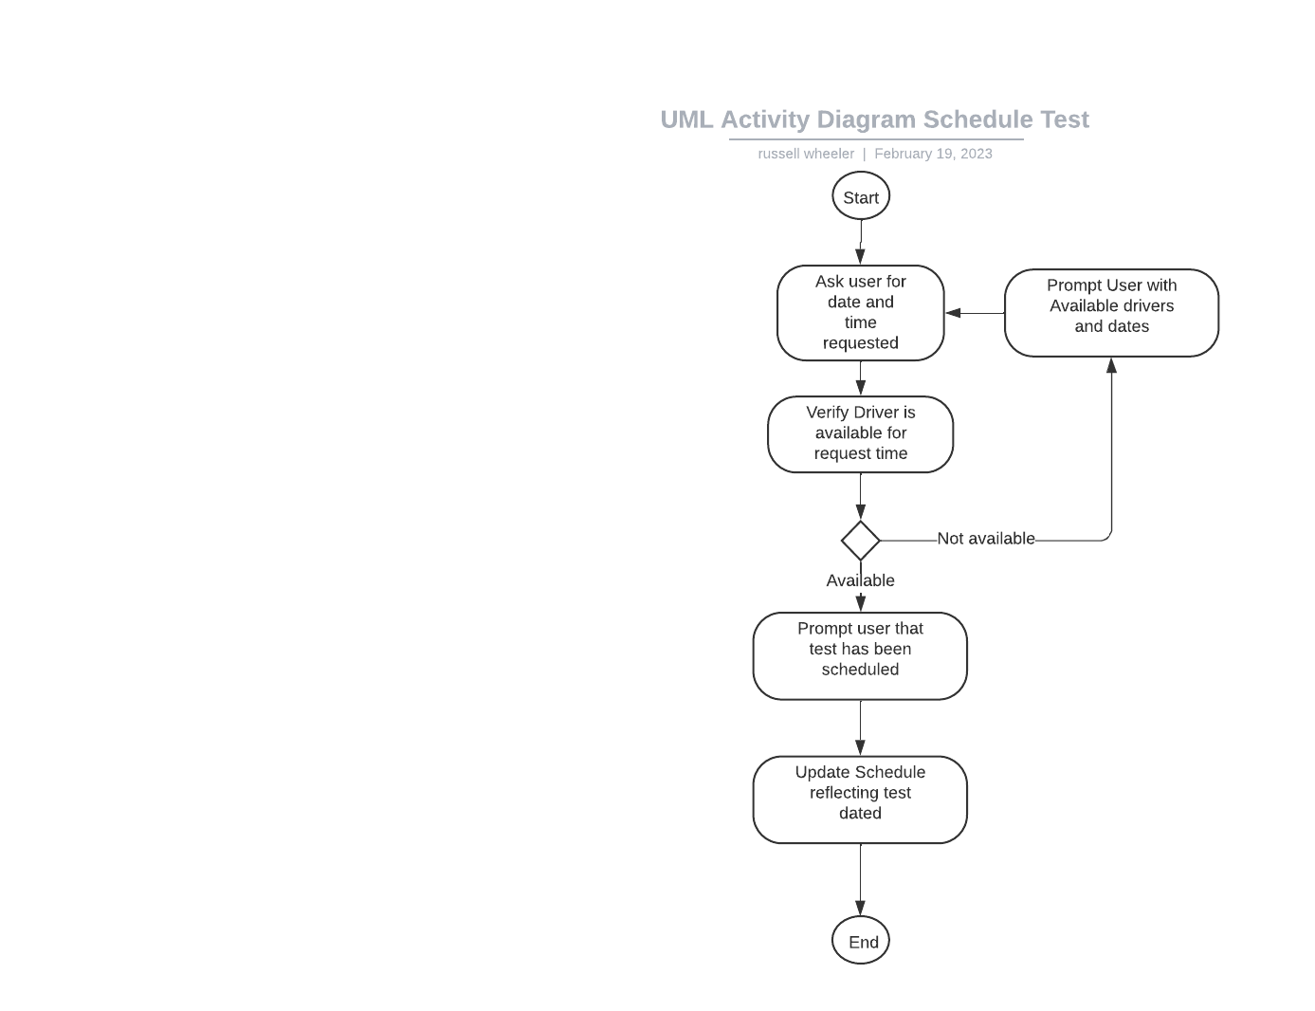

### UML Sequence Diagram

*]*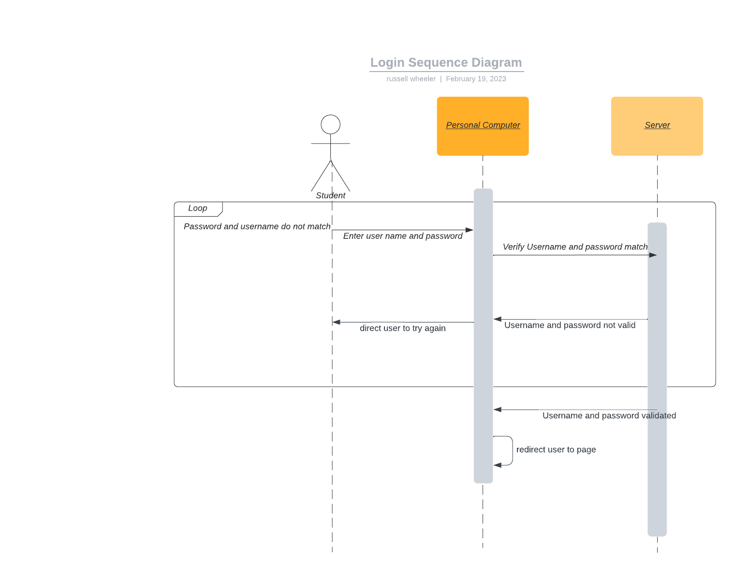

### UML Class Diagram

*]*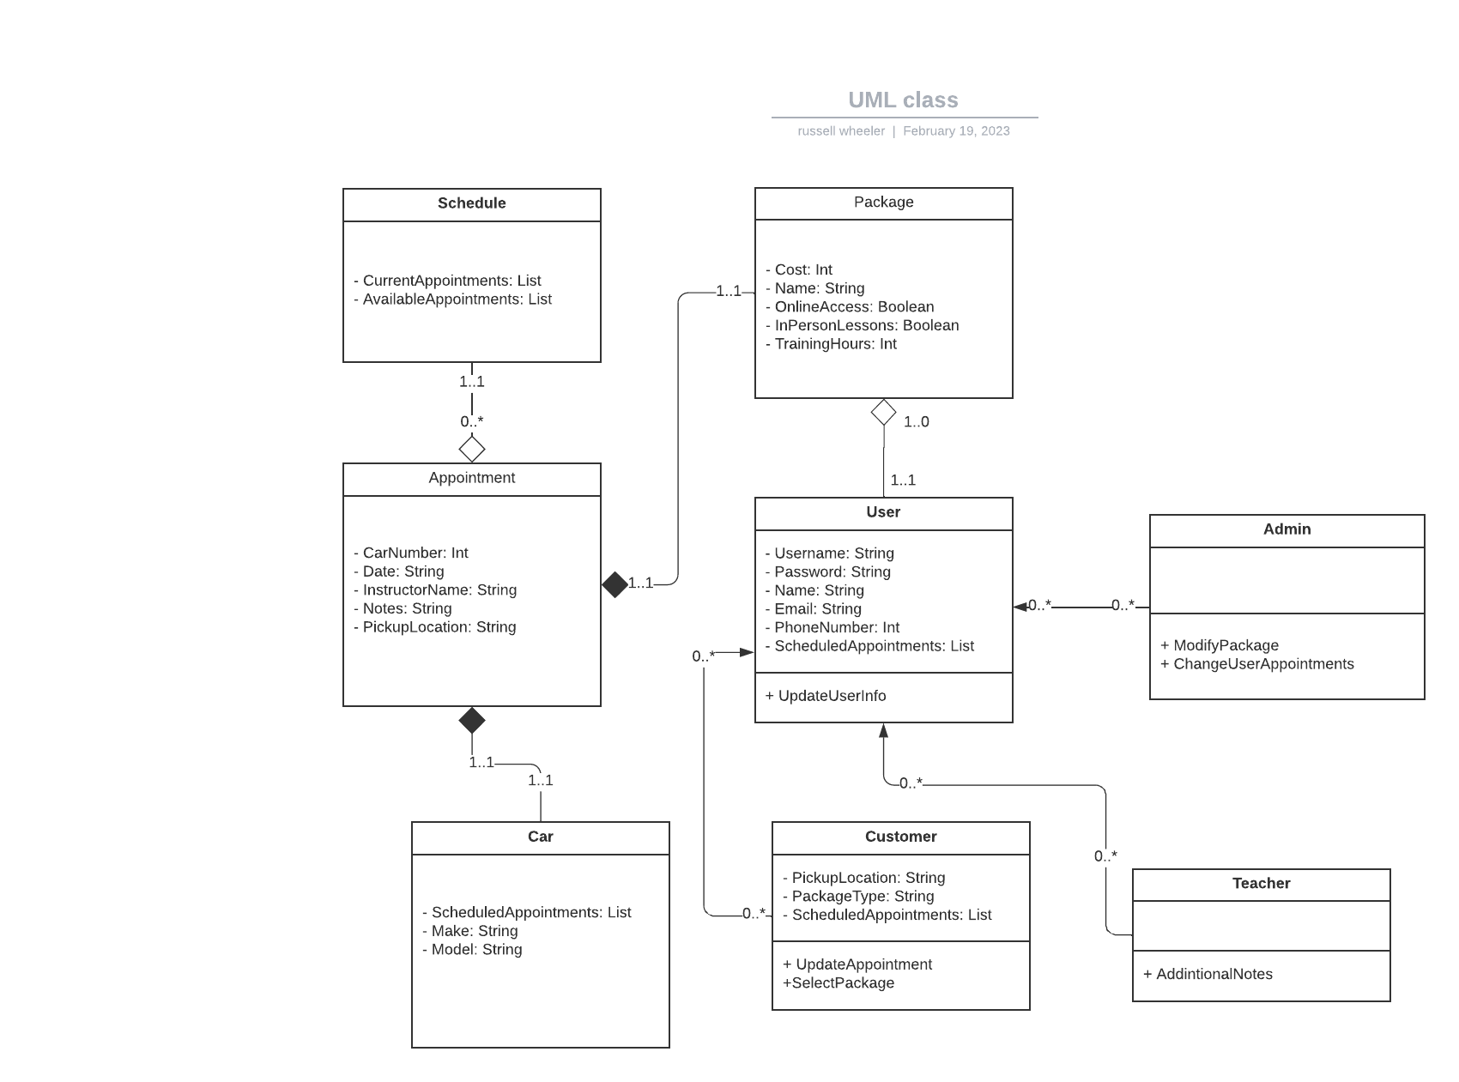

## Technical Requirements

*The Technical requirements of DriverPass are not unlike most online programs. The Program will require a server that will update info in real time so drivers will know if they have an appointment. The website would need to be able to be accessed from budget hardware to not prevent students from accessing the service. The website should be windows, IOS, and Android compatible to allow students to book appointments from anywhere. To create this program the developers will need to use an IDE for development, such as Eclipse or PyCharm. The above are the minimum requirements for developing and maintaining this program; however, more will depend on any future client demands.*